SUN PRotection policy
Policy number:  Updated by: | 37  Shelley Bussell | Version:  Updated on: | V4.0  11/05/21
Responsible person: | CFC Executive Director | Approved by CoM on: | Pending: 26th August 2021
Review frequency | 2 years | Scheduled review date: | May 2023

Purpose
This policy provides guidelines to ensure:
- all children, clients, employees, volunteers and visitors at Craig Family Centre (CFC) are protected from over-exposure to UV radiation;
- the CFC outdoor environment provides shade for children, clients, staff and visitors;
- children are encouraged and supported to develop independent sun protection skills;
- duty of care and regulatory requirements are met; and
- appropriate OHS strategies to minimise UV risk and associated harms for children, clients, staff and visitors to CFC.

Policy statement

Values
The CFC is committed to:
- promoting sun protection strategies at the Centre to minimise the harmful effects of over exposure to UV radiation
- ensuring that curriculum planning will minimise overexposure to UV radiation and also promote an awareness of sun protection and sun safe strategies
- providing information to children, staff, volunteers, parents/guardians and others participating in CFC programs and activities about the harmful effects of exposure to the sun’s UV radiation.

Scope
This policy applies to all CFC employees, contractors, students on placement, volunteers, parents/guardians, children and others attending the programs and activities of CFC.
This policy will apply from mid-August until the end of April each year or when the UV index is 3 or above.

Background & LEGISLATION
Over exposure to the sun’s UV radiation can cause sunburn, skin and eye damage and skin cancer. Australia has one of the highest rates of skin cancer in the world.
Children up to four years of age are particularly vulnerable to UV damage due to lower levels of melanin and a thinner stratum corneum (the outermost layer of skin). UV damage accumulated during childhood and adolescence is associated with an increased risk of skin cancer later in life.
A combination of sun protection measures (hats, clothing, sunscreen, shade and sunglasses) is recommended whenever UV levels are three or higher during daily sun protection times (refer to Definitions).
It is a requirement under the Occupational Health and Safety Act 2004 that employers provide a healthy and safe environment for all persons who access the service’s facilities and/or programs.
Legislation that governs the operation of approved children’s services is based on the health, safety and welfare of the children and requires that children are protected from hazards and harm.

Legislation and standards
Relevant legislation and standards include but are not limited to:
- Child Wellbeing and Safety Act 2005 (Vic) (Part 2: Principles for Children)
- Education and Care Services National Law Act 2010: Section 167
- Education and Care Services National Regulations 2011: including Regulations 100, 101, 113, 114, 168(2)(a)(ii)
- National Quality Standard, Quality Area 2: Children’s Health and Safety
- Occupational Health and Safety Act 2004

Definitions
The terms defined in this section relate specifically to this policy.
Clothing for sun protection: Clothing that is loose-fitting, made from cool, densely woven fabric and covers as much skin as possible: tops with elbow-length sleeves and, if possible, collars and knee-length or longer shorts and skirts. Singlet tops and shoestring tops/dresses do not provide adequate protection in the sun.
Daily sun protection times: Times when it is estimated that the sun’s UV radiation will be three or higher. Information about the daily sun protection times is available in the weather section of the daily newspaper, on the SunSmart website at: www.sunsmart.com.au, at myuv.com.au, as a free SunSmart app and as a free widget that can be added to websites.
Shade: An area sheltered from direct and indirect sun, such as a large tree, canopy, veranda or artificial cover. Shade can be built, natural or temporary and can reduce overall exposure to the sun’s UV by 75%. When combined with appropriate clothing, hats and sunscreen, children can be well protected from UV over exposure when outdoors. Research shows that preschool environments with trees, shrubbery, and broken ground not only provides better sun protection in outdoor play but also triggers more physical activity.
Sunhat: SunSmart recommends broad-brimmed, legionnaire or bucket-style hats that shade the face, neck and ears. Baseball caps and visors offer little protection to the cheeks, ears and neck, and are not recommended.
Sunglasses: Sunglasses are optional. If worn, it is recommended that glasses are a close fitting, wrap-around style that meet the Australian Standard 1067 (Sunglasses: Category 2, 3 or 4) and cover as much of the eye area as possible. Wearing a hat with a brim that shades the eyes can also reduce UV radiation to the eyes by 50%.
Sunscreen: SPF 30 (or higher) broad-spectrum, water-resistant sunscreen. Sunscreen should be reapplied every two hours, even when labelled 4 hours water resistance. Monitor the expiry date and store in a cool, dry place. From 3 years of age, children are encouraged to apply their own sunscreen under supervision of staff to help develop independent skills ready for school.
SunSmart: The name of the program conducted by Cancer Council to help prevent skin cancer: www.sunsmart.com.au

Sources and related policies

Sources
- AS/NZS 4685.0:2017, Playground equipment and surfacing - Development, installation, inspection, maintenance and operation.6.2.1 General considerations, 6.3.9 Shade and sun protection, Appendix A Shade and sun protection
- Safe Work Australia: Guide on exposure to solar ultraviolet radiation (UVR) (2019)
- Cancer Council Australia: www.cancer.org.au/sunsmart
- Get Up & Grow: Healthy eating and physical activity for early childhood. Department of Health resources. Particularly Section 2 of the Director/Coordinator Book and the Staff Book: http://www.health.gov.au/internet/main/publishing.nsf/Content/phd-early-childhood-nutrition-resources
- SunSmart: www.sunsmart.com.au
- Victorian Institute of Teaching (VIT) The Victorian Teaching Profession Code of Conduct - Principle 3.2
- Australian Professional Standards for Teachers (APST) – Standard 4.4 and 7.2
- ARPANSA Radiation Protection Standard for Occupational Exposure to Ultraviolet Radiation (2006)
- Belonging, Being and Becoming – The Early Years Learning Framework (July 2009)
- Victorian Early Years Learning and Development Framework (VEYLDF) (May 2016)
- Victorian School Building Authority (VSBA) Building Quality Standards Handbook (BQSH): Section 5.1.4 Shade Areas (2020)
- AS 4174:2018 Knitted and woven shade fabrics
- AS/NZS 1067.1:2016, Eye and face protection - Sunglasses and fashion spectacles
- AS 4399:2020, Sun protective clothing – Evaluation and classification
- AS/NZS 2604:2012 Sunscreen products - Evaluation and classification
- Australian Government Therapeutics Goods Administration (TGA) – Australian regulatory guidelines for sunscreens: 4. Labelling and advertising – directions for use of the product

Service policies
- Excursions and Service Events Policy
- Nutrition, Oral Health and Active Play Policy
- Occupational Health and Safety Policy
- Supervision of Children Policy

Procedures

Creating a Healthy physical environment
- The CFC Committee of Management (CoM) is responsible for ensuring there is a sufficient number of shelters and trees providing shade in outdoor play areas. (Regulation 114)
- The CFC will maintain membership of SunSmart and participate in shade audits of the current availability and quality of shade.
- The CoM will ensure shade provision is considered in future building plans and upgrades

Creating sunsafe behaviours

Sun protective clothing
- During the months of September to April, children are required to wear loose-fitting clothing that covers as much skin as possible.
- tops with elbow-length sleeves,
- higher necklines (or collars)
- knee-length or longer style shorts or skirts
- The Executive Director is responsible for ensuring families/guardians are reminded of clothing requirements through the CFC newsletter at the end of Term 3 and beginning of Term 1.
- If a child attends children’s service wearing clothes that are not sunsafe e.g. singlet top or shoestring dress, educators will remind the parent/guardian of the sunsafe clothing requirements. The child will be asked to choose a t-shirt/shirt from the CFC communal supply to wear over their clothing before going outdoors.

Hats outside
- All children are required to wear hats that protect their face, neck and ears (legionnaire or broad-brimmed style). Peak caps, narrow brimmed bucket hats and visors are not considered a suitable alternative.
- Hats are to be labelled and kept separately in each child’s possessions.
- If a child does not have a hat, one will be supplied from the CFC communal supply. Communal hats must be laundered after use.
- To help develop independent skills ready for school, children from three years of age will be encouraged to take the initiative to put on their hat with minimal direction when preparing to go outside.

Sunscreen
- SPF30 (or higher) broad-spectrum, water-resistant sunscreen is supplied by the CFC. This is available in each of the children’s services rooms. Staff must ensure sunscreen is stored in a cool place and regularly check the expiry date.
- In CFC kindergarten and/or occasional care programs, educators are responsible for ensuring sunscreen is applied at least 20 minutes (where possible) before going outdoors and reapplied if required i.e. if waterplay is undertaken
- To help develop independent skills ready for school, children from three years of age are to be given opportunities to apply their own sunscreen under supervision of staff and are encouraged to do so.

Choose shade
- During terms 1 and 4, children are encouraged to choose and use available areas of shade when playing outside for outdoor equipment that is not fixed

sun gear is put away from may to august
- Vitamin D is essential for healthy bones, muscles and general wellbeing. The best natural source of vitamin D is the sun’s UV. From May to August when UV levels are low (below 3), the CFC follows SunSmart advice and sunhats and other sun protection gear away is put away to ensure staff and children get some sun for vitamin D.

Learning and skills
- The Educational Leader will ensure kindergarten and occasional care programs incorporate sun protection at the beginning of Term 1 and 4.
- The SunSmart policy is to be reinforced by educators and through children's activities and displays.

Modelling SunSafe Behaviour
- CFC staff and volunteers must model SunSafe practices by wearing sunhats, clothing for sun protection and sunglasses (optional) when outside, applying sunscreen and seeking shade between the months of September to April or when the UV factor is 3 or above

Engaging children, educators, staff and families
- Educators, staff and families are provided with information about the CFC SunSafe Policy and Procedures and sun protection through CFC newsletters, handbooks, noticeboards and the CFC website.

Festivals and outdoor events
- When planning festivals or other outdoor events, CFC will consider UV radiation as part of safety and risk management (refer to Attachment 1).

Parents and Guardians
Parents and guardians are:
- informed of the CFC SunSmart policy in the Children’s Services Handbook;
- asked to provide a suitable sun protective hat, covering clothing and to apply sunscreen to their child before the commencement of each session from September to April;
- asked to give permission for educators to apply sunscreen to their child, if they are enrolled in CFC kindergarten and/or occasional care programs (refer to the CFC Enrolment Form or Attachment 2); and
- if assisting with activities at the CFC asked to model good sun safe behaviour during the months of September and April by wearing a sunhat, clothing for sun protection and sunglasses when outside at the Centre, applying sunscreen and seeking shade.

Evaluation
In order to assess whether the values and purposes of the policy have been achieved, the CFC will:
- regularly seek feedback from all affected by the policy regarding its effectiveness
- monitor the implementation, compliance, complaints and incidents in relation to this policy
- revise the policy and procedures as part of the service’s policy review cycle, or as required
- notify parents/guardians at least 14 days before making any change to this policy or its procedures.

related policies
Craig Family Centre policies
- Excursions and Service Events Policy
- Nutrition and Active Play Policy
- Occupational Health and Safety Policy
- Supervision of Children Policy
- Curriculum Development Policy

Attachments
- Attachment 1: Sunsmart festivals and outdoor events checklist
- Attachment 2: Authority for staff to administer sunscreen
ATTACHMENT 1
SunSmart festivals and outdoor events checklist
Source: Sunsmart website: http://www.sunsmart.com.au
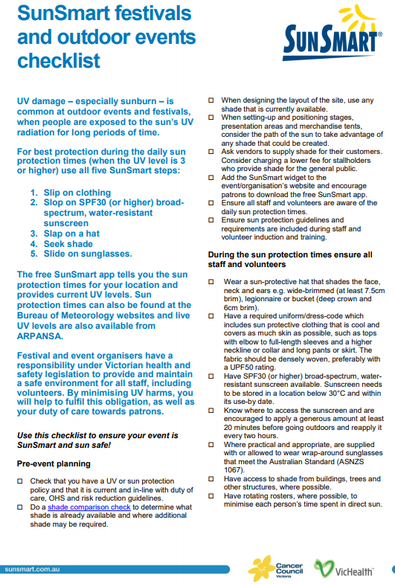
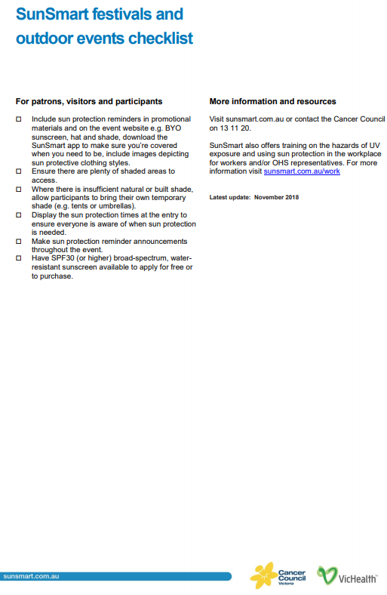

ATTACHMENT 2
Authority for staff to administer sunscreen
Authority for staff to administer sunscreen provided by the service
I, , give/do not give permission for the staff at the Craig Family Centre to apply, as appropriate, SPF 30+ or higher, broad-spectrum, water-resistant sunscreen to all exposed parts of my child’s body.

(Name of child)

Signature (parent/guardian)

Date

Authority for staff to administer sunscreen provided by the parent/guardian
I, ,give permission for the staff at the Craig Family Centre to apply, as appropriate, to all exposed parts of my child’s body the sunscreen that I have supplied and labelled with my child/children’s name. This sunscreen is an SPF 30+ or higher, broad-spectrum, water-resistant sunscreen. I understand that this sunscreen will be kept at the service.
It is my responsibility to ensure there is always an adequate supply of this sunscreen at the service.

(Name of child)

Signature (parent/guardian)

Date

